Older People’s Day 2016

“The role of physiotherapists in helping older people stay healthy and independent”

Neuro Rehabilitation Kent will be joining in this annual event by providing a lively and interactive free talk by Sevenoaks based physiotherapist Jane Cast
It will include
- Practical advice and tips on improving your balance
- How to prevent falls
- Getting fitter
- How to stay motivated.
Refreshments and cake will be provided
WHEN: Monday October 3rd
WHERE: Gloucester House Nursing Home
Lansdowne Road, Sevenoaks TN13 3XU
TIME 3-4pm
Please confirm your attendance:
Email: jane@neurorehabkent.com
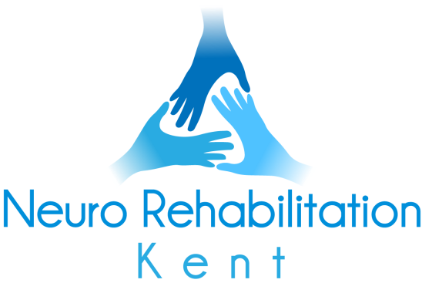
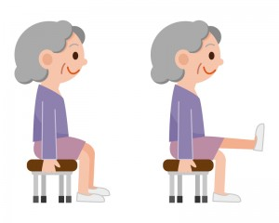
Phone: Gloucester House Reception 01732 741488

